**IFT 266 Introduction to Network Information Communication Technology (ICT)   
  
Lab 37**

**Wireless IPv6 Autoconfiguration**

Co-authored by Jacob Woody

**After you complete each step, put a ‘√’ or ‘x’ in the completed box**

In a recent report by Cisco, wireless was one of the five technologies that are shaping the modern network.

This lab will show you how to implement a wireless environment using the IPv6 protocol.

1. Set up the following topology in packet tracer. Make sure that you select the correct Access Point as indicated on the topology.

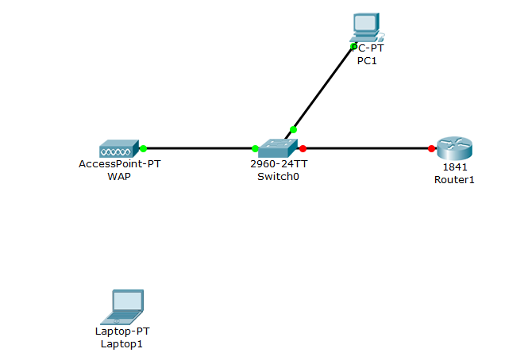

1. Currently the laptop has an Ethernet module in place. In order to connect to the Wireless Access Point (WAP) we will need to swap the existing module for the wireless module. To do this, first power off the laptop, then remove the Ethernet module and replace it with the WPC300N. Then you can power the laptop on again.
2. We will now connect the laptop to the WAP. Go back into to the desktop tab on the laptop, select PC Wireless and then the Connect tab. Refresh until the WAP appears, the default SSID is “Default”. Select this network and click Connect.   
     
   Laptop is now connected to the WAP and we can begin configuring the router.

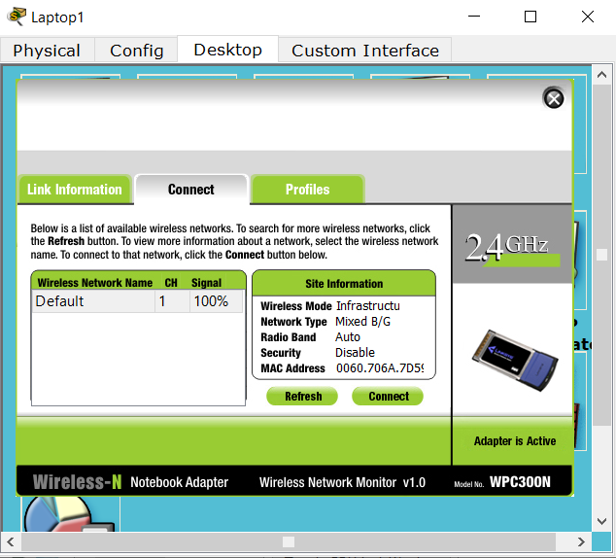



1. We now need to configure the router to enable IPv6 unicast routing and give it an IPv6 address.  
     
   Enter the following commands on the router:

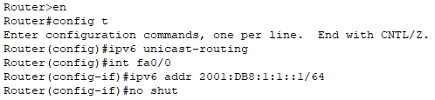

1. We have now enabled unicast routing on the router, which will allow us to use autoconfiguration to provide an IPv6 address on the PC and the Laptop.
2. Go back to the laptop, and retrieve an IPv6 address using auto-config option.

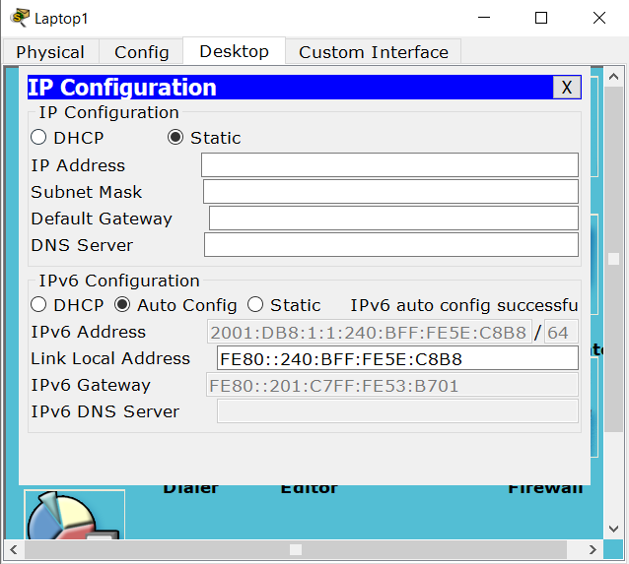



1. Repeat the same step on the PC.

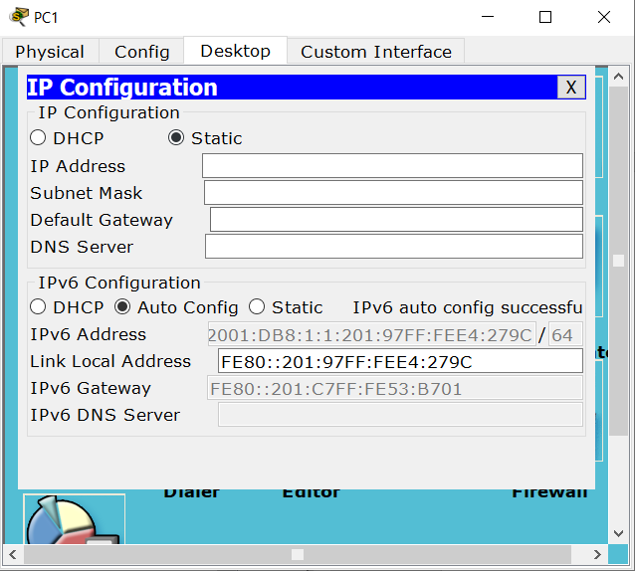



1. You should be able to ping the PC from the laptop using the PC’s IPv6 Address.
2. You can copy the last four blocks of the link local address (from the PCs configuration) to save you from typing it all in the command line, just replace the first four blocks with 2001:DB8:1:1

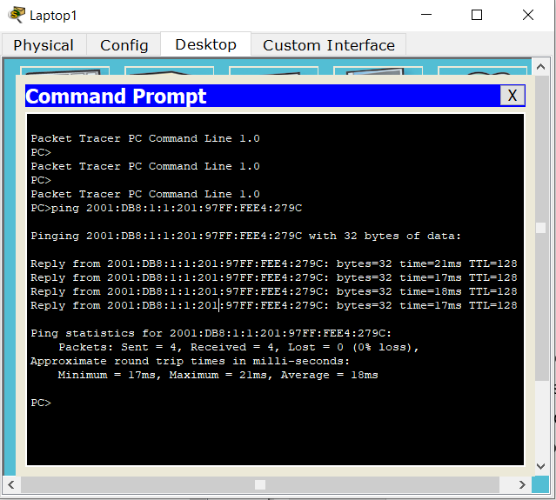



1. Finally, add and connect another laptop to the WAP, get its auto configured unicast address as you did previously and ping it from the existing wireless laptop.   
     
   Provide a screen shot of your updated topology with this additional wireless laptop below.

